2.81: a) The football will go an additional 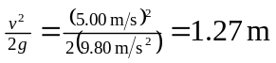 above the window, so the greatest height is 13.27 m or 13.3 m to the given precision.

b) The time needed to reach this height is 